2a. 

[1] 0.9949

2b.





As seen in the figure, the conclusions about the event are not very sensitive to the prior distribution on theta B. Even when n0 gets up to 50, the probability only drops to about 0.75.

2c.

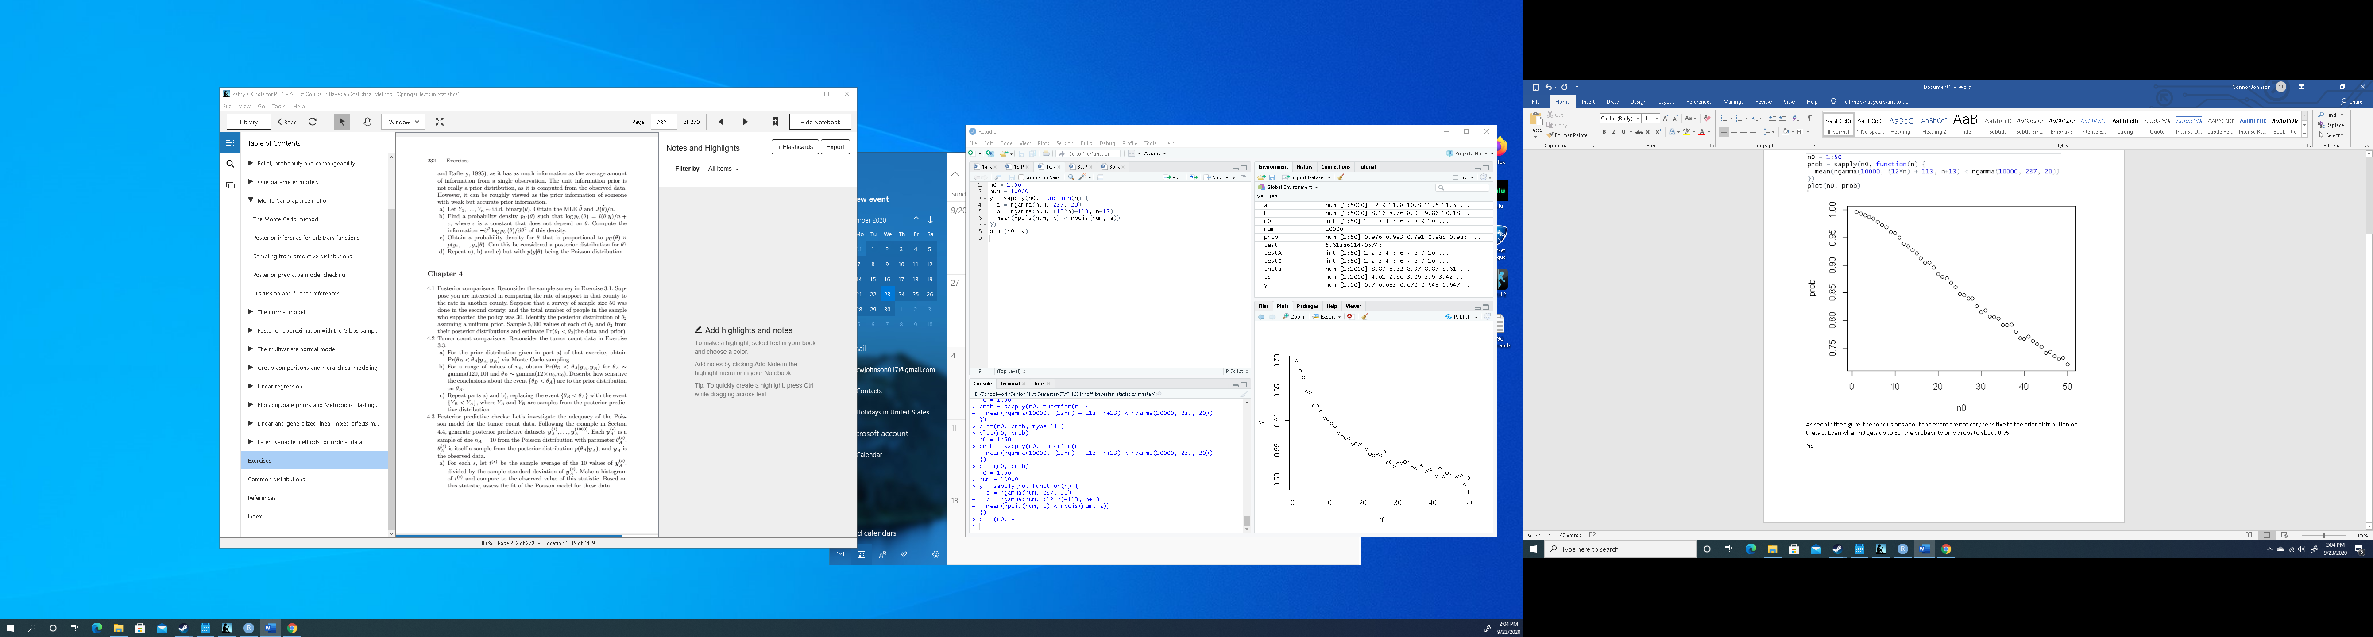



3a.

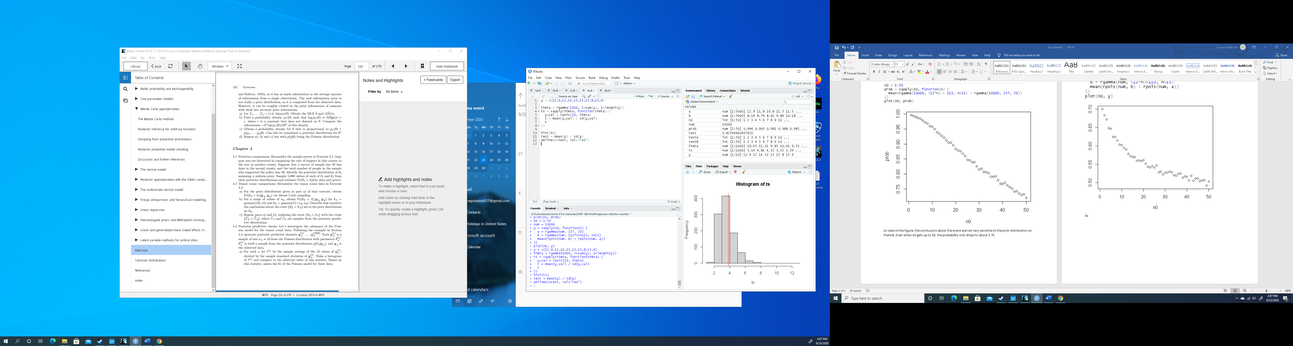



Since the test statistic of the data is well centered on the histogram of all the t values, there is no reason to suggest that the Poisson model is a bad fit for the data.

3b.





Since the test statistic of the y data appears to be an outlier among the t values, it would suggest that the Poisson model is a bad fit for this data set.